
XR Simulation Learning Platform
Functional Requirement Document
Consolidated Updated Draft — Version 5.0
Team Lead Review Summary

What changed, what was confirmed, and what needs a decision
Status | DRAFT FOR REVIEW — NOT YET APPROVED
Date | 19 August 2026

The original Platform FRD_v4 remains unchanged. This consolidated draft preserves the original requirement IDs, records approved PM clarifications and additions, and identifies pending decisions for stakeholder review.

1. What This Is, and What It Is For
Read this document to answer two questions
• What changed in our understanding of the project, and why.
• What needs a decision from you or from the Project Manager before detailed design continues.

It is short and deliberately incomplete. It does not contain requirements — it contains the shape of the work and the decisions outstanding. Anything you want to check in detail is in one of the two companion documents.
- Core FRD — the primary review document. Read it to understand what is being built. About 30 pages.
- This summary — the discussion document. What changed and what needs decisions.
- Detailed Requirements and Traceability Reference — all 131 original requirements, the traceability matrix, every acceptance criterion and the full registers. Use it when you need exact provenance. Long by design.
- Platform FRD_v4 — the historical issued source. Unchanged.

1.1 The project in one paragraph
We are building one web platform that delivers engineering simulation experiments to students — some running in a browser, some on a VR headset, some on a phone. Experiments come from outside vendors and have to pass academic and technical review before anyone can use them. Access reaches a learner in one of two ways: an institution buys a licence and its faculty assigns content, or an individual buys a module for themselves. Seven kinds of user each get their own area of the same platform.

1.2 Status
Table 1 — Where this stands
Field | Value
Status | DRAFT FOR REVIEW — NOT YET APPROVED · 19 August 2026
Original FRD | source/Platform FRD_v4.pdf — unchanged. Nothing in this work edits it
What is confirmed | Fifteen stakeholder decisions, taken on 18 and 19 August 2026. This document set is not — it is a review draft, and the original FRD remains the issued baseline
Open questions | 59 recorded, of which 12 are high-priority. None blocks the architecture. Twelve need owners

2. What the Earlier Reading Missed
The design work that followed the original FRD was done on the understanding that the detailed Phase-1 scope was the student's desktop experience. On 18 August 2026 the Project Manager confirmed that this was too narrow: all Phase-1 requirements and all Phase-1 roles are in scope.
Table 2 — Old understanding against updated understanding
 | Old understanding | Updated understanding, and what it means
Requirement breadth | 78 Phase-1 requirements | Unchanged — still 78. Nothing was missed at the requirement level
Roles in design scope | One — the student | Seven. Six areas of the platform had never been looked at
Content governance | Background system behaviour | A four-gate workflow across four roles — the most precisely specified area in the FRD, and the least designed
Institutional side | Effects designed; causes not | The institution's own setup is in scope. Single sign-on, ERP, licences and assignment all need somewhere to happen
XR access | The portal named the required device | An entitled experiment must be able to reach the device. Already an FRD requirement; it had no designed experience
Assessment values | Fixed numbers, treated as constants | Configuration set by faculty. The FRD never stated a single one of those numbers
The earlier learner work | Was the product | Is one area within the platform, and is reusable. Nothing was wasted — no visual design had been produced

The one thing to take from this page
• The correction was not about missing requirements. It was about depth of role coverage — the same 78 requirements, looked at from seven perspectives instead of one.
• It cost almost nothing, because no detailed visual design had been produced when the scope was corrected.

A follow-up session on 19 August 2026 closed the three most structural remaining unknowns: where the content-side roles sit relative to institutional data, whether submitted content can be sent back for correction, and who owns assessment setup. All three are now confirmed positions rather than working assumptions.

3. What the Platform Looks Like, and Who Uses It
One platform, one shell, seven role-based areas. Content is made and governed centrally; each institution's data sits in its own isolated area; individual learners sit outside every institution. One role — the Super Admin — spans everything.
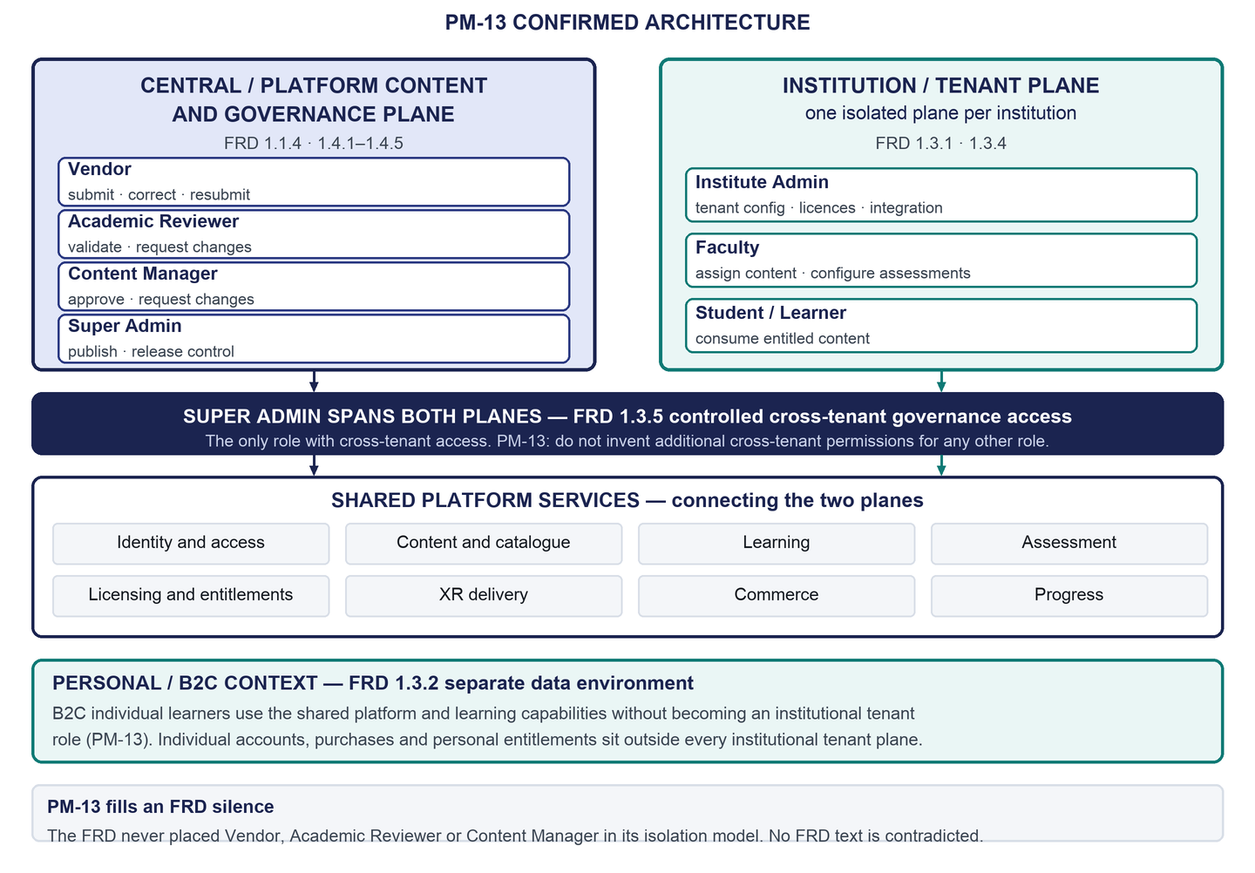
Figure 1 — Two-plane platform architecture confirmed by PM-13
Table 3 — The seven roles
Role | Sits on | What they do
Vendor | Central content side | Uploads an XR experiment, and corrects it if it comes back. Can never publish
Academic Reviewer | Central content side | Decides whether it teaches the right thing. Can send it back with reasons
Content Manager | Central content side | Checks the files, metadata and compatibility. Can send it back with reasons
Super Admin | Spans everything | The only role that can publish. Also licensing, platform configuration and cross-institution oversight
Institute Admin | One institution | Sets the institution up: single sign-on, ERP, student access, licence seats
Faculty | One institution | Assigns content and sets up assessments. Sees who is stuck
Student / Learner | An institution, or alone | Works through resources, simulation and assessment

The three content-side roles never touch institutional data, so they hold no access to it. Only the Super Admin crosses institutions, and the FRD limits even that to governance and operational oversight. Seven formal roles are currently approved for Phase 1; any additional Phase-1 formal role requires explicit stakeholder approval.

4. How Content Reaches a Learner
Nothing reaches a learner until it has been published, and publication takes four decisions by four different people. This is the most precisely specified sequence in the original FRD — and, because three of its four actors were outside the earlier scope, it had no design at all.
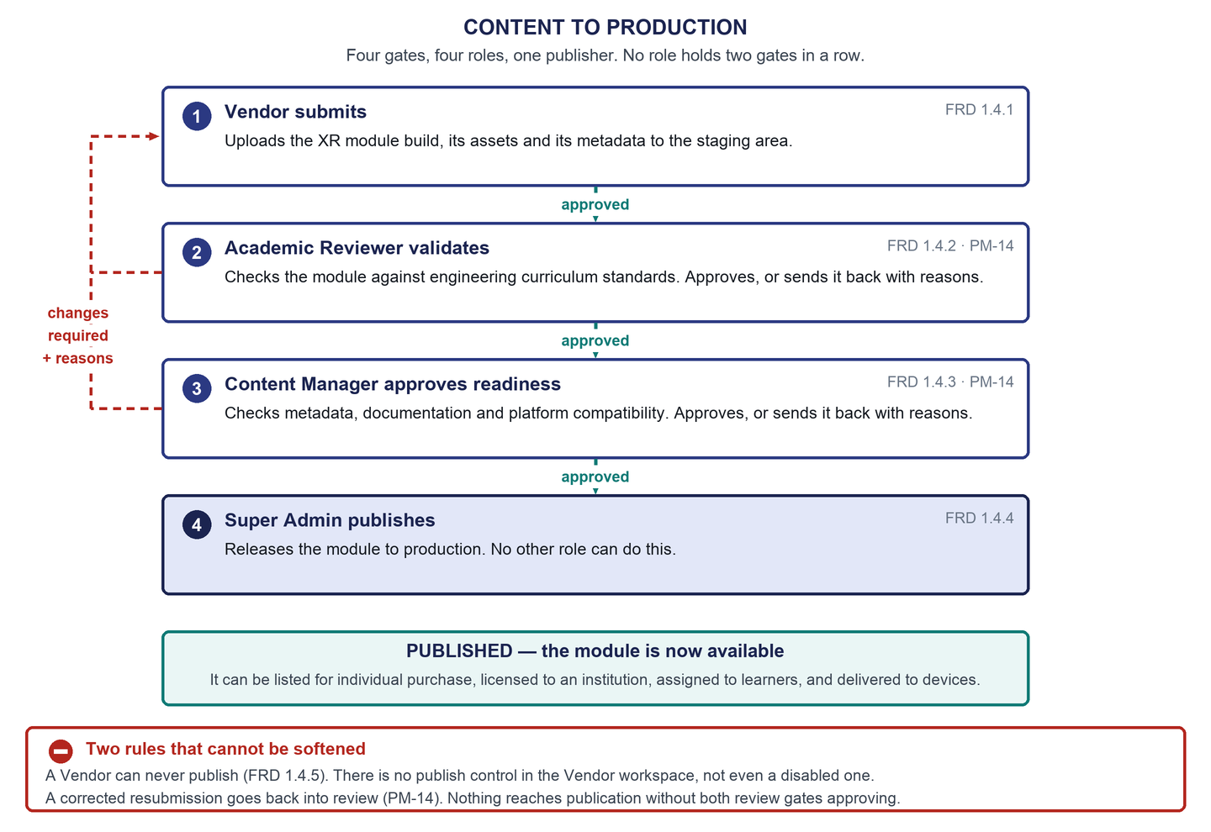
Figure 2 — Content to production — four gates, four roles, one publisher
- Three approvals, three roles, one publisher. No role holds two gates in a row.
- Two of the roles can send work back. That was added by stakeholder decision — the FRD's chain only moved forward, and a gate that can only approve is not a gate.
- Sending work back does not confer publishing authority. A reviewer can return a submission but can never push it forward past their own gate.
- Every decision is traceable. The vendor always sees where their submission is and why it came back.
The two gaps left in this workflow
• Nobody owns the validation criteria. The FRD requires alignment with engineering curriculum standards and never says what they are. The gate is fully designed; it cannot operate until someone writes the standard.
• The submission package format is undefined. The FRD says “encrypted asset bundles” and nothing more, so a vendor cannot yet be told precisely what to upload.

5. The Two Ways In, and What They Share
Both routes are Phase 1 and neither comes first. They differ in how access is granted and where the data lives; they share the entire learning experience.
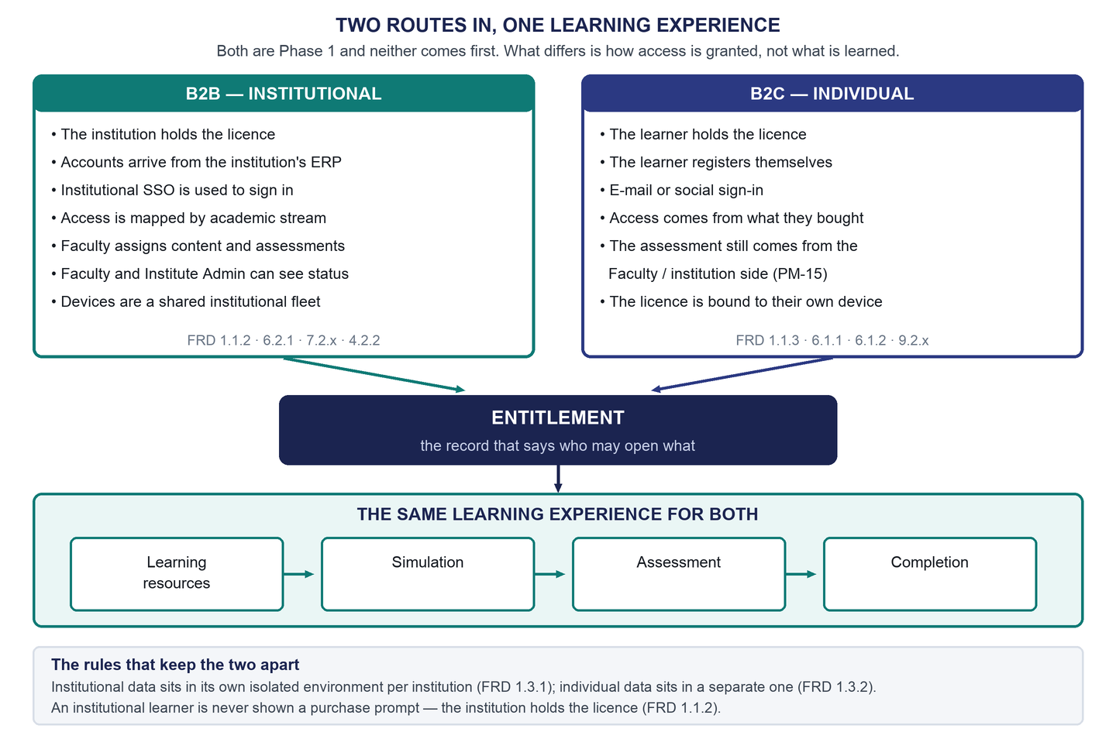
Figure 3 — Two routes in, one learning experience — B2B and B2C converging on one entitlement
The useful way to think about it is that both routes produce the same object — an entitlement, the record that says who is allowed to open what. Everything downstream reads that one record: learning checks it, XR delivery validates against it twice, progress is recorded against it.
Where the real asymmetry is
• It is not between the two markets. Both learner journeys were in reasonable shape.
• It is between the learner and everyone else. What was missing was the institutional machinery behind the institutional route — because the roles that operate it were outside the earlier scope.

6. How XR Access Works
An experiment a learner is entitled to has to be able to become available on the device that runs it. That requirement is confirmed, and the original FRD already implies it: modules download only after licence validation, and require licence validation again before they execute. What was missing was any designed experience for it.
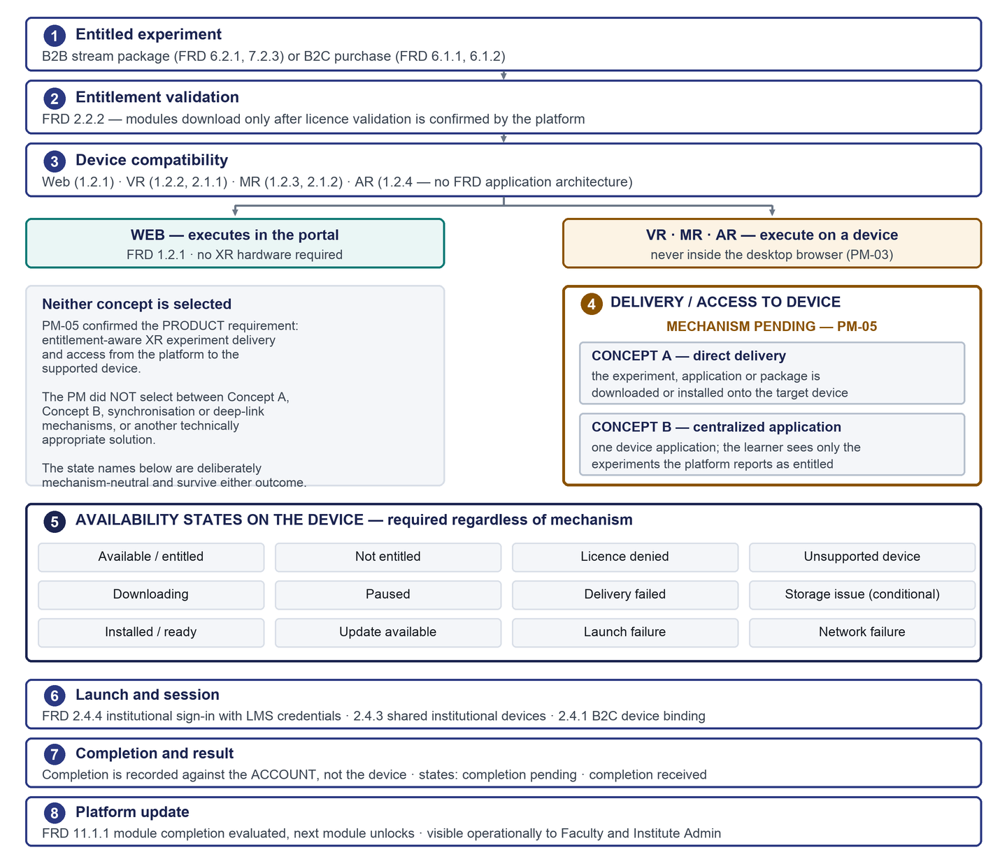
Figure 4 — FLOW 5 — XR entitlement and device-delivery lifecycle
The important thing to understand about this page
• The requirement is confirmed. The mechanism is deliberately not chosen. Two concepts were described — deliver the package to the device, or put one application on the device that shows only entitled experiments — and neither was selected.
• So the document specifies the states a learner must be able to see, in wording that stays true under either outcome, and names no transport, protocol or file format.
• The FRD defines no application architecture for augmented reality at all. That is a genuine gap: there is nothing to build against for the mobile format, and it is flagged rather than filled.

7. How Assessments Work
Assessments are configured, not fixed. Faculty or the authorised institution side sets them up, for institutional and individual learners alike. A learner never authors or configures one.
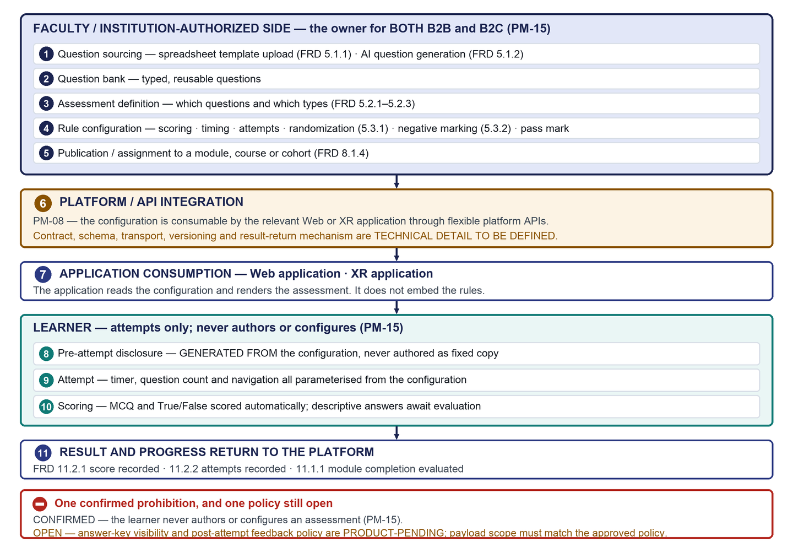
Figure 5 — FLOW 4 — assessment configuration to result
What changed here, and what did not
• Changed: the numbers. Question count, time limit, scoring, pass mark and attempt limit are configuration fields, not platform constants. The original FRD never stated a single one of them, so any specific value from earlier prototype work is a sample and nothing more.
• Did not change: the learner-facing screens. Their structure survives untouched. What changes completely is where their numbers come from — the pre-attempt disclosure now has to be generated from the configuration, because fixed copy would be untrue when a setting is turned off.
• Still open: who marks short descriptive answers, and what feedback a learner may see after an attempt. Neither is defined by any source, and neither is invented here.

8. What Changed, and What the Stakeholder Confirmed

8.1 The fifteen confirmed decisions
Table 4 — PM-01 to PM-15
ID | What was confirmed
PM-01 | All Phase-1 requirements and all Phase-1 roles are in scope.
PM-02 | Sitemap, then permissions, then all-role workflows, then priority flows into detailed design.
PM-03 | One central platform and portal with role-based access and workspaces — and not every XR runtime is in a browser.
PM-04 | Both institutional and individual models are required. Neither is sequenced first.
PM-05 | An entitled XR experiment must be able to reach the supported device. The mechanism is not selected.
PM-06 | The required simulations exist. The platform ingests and governs them rather than authoring them.
PM-07 | Vendor and Academic Reviewer get real logins and their own workspace.
PM-08 | Assessment behaviour is configured through the portal and consumed by applications through flexible APIs.
PM-09 | The learning sequence is approved: resources, simulation, assessment, completion.
PM-10 | Institutional single sign-on is required.
PM-11 | Core operations first. Detailed reporting and analytics are added incrementally.
PM-12 | Certification is not Phase 1. It is a Phase-2 activity.
PM-13 | The two-plane model is confirmed: a central content side, isolated institution sides, the Super Admin spanning both.
PM-14 | Submitted content can be sent back with comments; the vendor corrects and resubmits; every decision is traceable.
PM-15 | Faculty or the authorised institution side owns assessment setup for both markets. A learner never configures one.

8.2 The four places this departs from the original FRD
Table 5 — Departures, each recorded rather than applied to the original
Type | Item | What it means
🔴 Deviation | Certification moves from Phase 1 to Phase 2 (PM-12) | The FRD puts certification structure and completion criteria in Phase 1. The stakeholder moved both. The original phase is preserved everywhere, and we do not claim the FRD always said Phase 2
🟠 Extension | Vendor and Academic Reviewer become roles (PM-07) | The FRD defines five roles and treats these two as actors with no permissions. The FRD's own mechanism for adding a role is a Phase-3 requirement, so it cannot justify this within Phase 1
🟠 Extension | Content can be sent back for correction (PM-14) | The FRD's governance chain only moves forward. Rejection, comments, resubmission and a review history are additions
✅ Conflict resolved | Single sign-on is required (PM-10) | The FRD contradicts itself — configuration in Phase 1, authentication support in Phase 3. The Phase-1 reading is confirmed and the original phase is preserved

8.3 Seven accuracy corrections in this revision
Seven claims in the first v5 draft asserted more than the sources support, and all have been corrected in every edition. None changes scope and none removes a requirement — each narrows what the document claims.
- Answer-key visibility is now recorded as PRODUCT-PENDING: post-attempt feedback policy is undecided, and a learner-facing application receives only what the approved policy permits. Previously a universal rule.
- Direct course purchase is now recorded as not specified — Phase-1 purchase requirements name modules and bundles, and course purchase is neither required nor prohibited. Previously a permanent prohibition.
- Assessment hints are now OPTIONAL and unapproved: no source defines them, and PM-08 does not name them.
- The sign-in and role-routing model is now a labelled design position, and a workspace chooser is conditional on multi-role identities being approved rather than mandated.
- The role set is now seven roles currently approved, with any addition requiring explicit stakeholder approval, rather than permanently closed.
- Institutional single sign-on is required and available per the institution's configured authentication model, rather than described as preferred.
- Three inherited design positions — cart-free checkout, standalone-module gating and the caption rule — are relabelled as design positions rather than requirements.
The reasoning behind each is in the Core FRD and in the Detailed Requirements and Traceability Reference.

9. What Is Still Unanswered
There are 59 open questions in total. None blocks the platform architecture, the role model or the workflows. Several do block development of a specific capability. The 12 high-priority items are below.
Table 6 — The high-priority open questions
ID | Class | Question | Owner | Blocks
QP-02 | Product | Who grades descriptive answers, on what turnaround, and against what rubric? | Project Manager with academic stakeholder | Development only
QP-04 | Product | How is an institutional licence transacted in Phase 1, given that institutional billing is Phase 2? | Project Manager with commercial owner | Development only
QP-27 | Product | What post-attempt feedback may a learner see, and is answer-key visibility ever permitted? | Project Manager with academic stakeholder | Development only
QT-01 | Technical | Which XR delivery mechanism is used? | Team Lead with Project Manager | Development only
QT-02 | Technical | There is no AR application architecture in Platform FRD_v4. What is it? | Team Lead | Development only
QT-03 | Technical | What is the assessment configuration API contract? | Team Lead | Development only
QT-04 | Technical | How does an SSO-authenticated learner sign into the XR application, which requires LMS credentials? | Team Lead with Project Manager | Development only
QD-01 | Data | Which profile fields are user-editable and which are ERP-owned? | Team Lead with Institute stakeholder | Development only
QD-02 | Data | What is the Phase-1 origin of role assignment? | Project Manager with Team Lead | Development only
QX-01 | Design | Does the desktop-first viewport decision extend to all six new workspaces? | Design lead with Project Manager | Detailed design
QX-02 | Design | How is the outstanding reflow non-conformance handled now that it spans all workspaces? | Design lead with Project Manager | Development only
QX-03 | Design | Who owns video captions, transcripts and audio description? | Project Manager with academic stakeholder | Development only

Four of these are open on purpose
• The XR delivery mechanism, the single-sign-on provider and protocol, which institution supplies an assessment for a purely individual learner, and the detailed reporting metrics were all deliberately left open by the stakeholder. They are not gaps in the analysis.
• The one to worry about is who marks short descriptive answers. It is the only open item that can leave a learner stuck mid-course through no fault of their own: the FRD allows descriptive questions, nobody owns marking them, and module completion gates the next module.

Medium and low-priority questions, with the safe working position recorded against each, are in the Core FRD and in full in the Detailed Requirements and Traceability Reference.

10. What Happens Next

10.1 Five decisions, ideally in one session
Table 7 — What we need from you and the Project Manager
# | Decision | Why it matters now
1 | Accept the consolidated scope and phasing, including the certification deviation and the single-sign-on resolution | Everything downstream is scoped against it. Without it, two readings of Phase 1 stay in circulation
2 | Accept the seven-role model and the two-plane architecture | Both are extensions of, or silences in, the original FRD. They should be accepted deliberately rather than assumed
3 | Give a direction on who marks short descriptive answers | The only open item that can strand a learner mid-course
4 | Give a direction on how an institutional licence is transacted in Phase 1 | Institutional billing is Phase 2, so Phase 1 needs licences to exist with no defined transaction
5 | Choose which end-to-end flows go into detailed design first | The architecture is complete, which was the precondition. A ranked recommendation exists but is not approved

10.2 In parallel, on the engineering side
- Schedule technical discovery on the XR delivery mechanism. It does not block design — the delivery contract is deliberately mechanism-neutral — but it blocks build.
- Raise the missing AR application architecture. It is the one place where there is no requirement to build against at all.
- Catalogue the existing simulations — formats, versions, device compatibility and who owns each one. The platform can be built to ingest and deliver content, but it has nothing to publish until this exists.
- Get the academic validation criteria owned and written. The review gate is designed and cannot operate without them.
What approval does and does not mean
• The agreed design sequence is sitemap, then role permissions, then all-role workflows, then priority flows into detailed design. The first three are done; the fourth waits on decision 5 above.
• Approving this document set accepts the scope, architecture, role model and recorded deviations as the working requirement baseline for Phase 1.
• It does not answer the open questions, it does not amend Platform FRD_v4, and it does not claim anything has been built or tested. Nothing here is implemented.

